Name:_______________________________ Class:__________
Home Work Term 1 WeeK 1

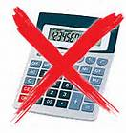
- Which if these has the same value as 18 × 37 – 26 × 18:
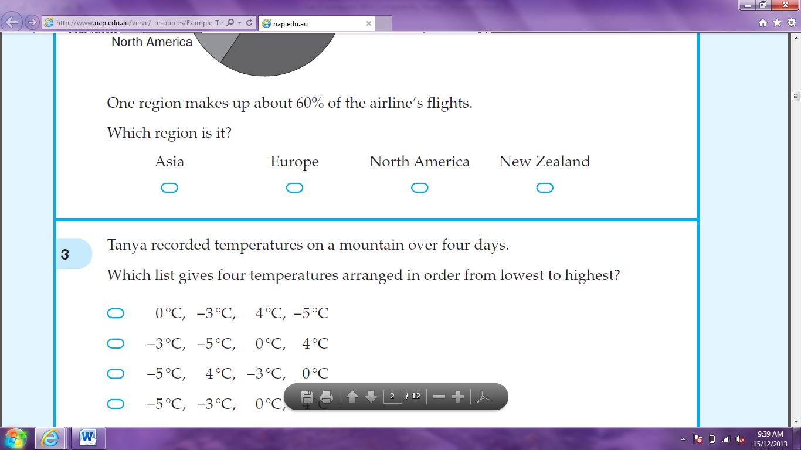



18 × 11 19 × 8 37 × 8 26 × 19

- A positive number was multiplied by itself and then 8 was subtracted. The answer was 17. What was the number?

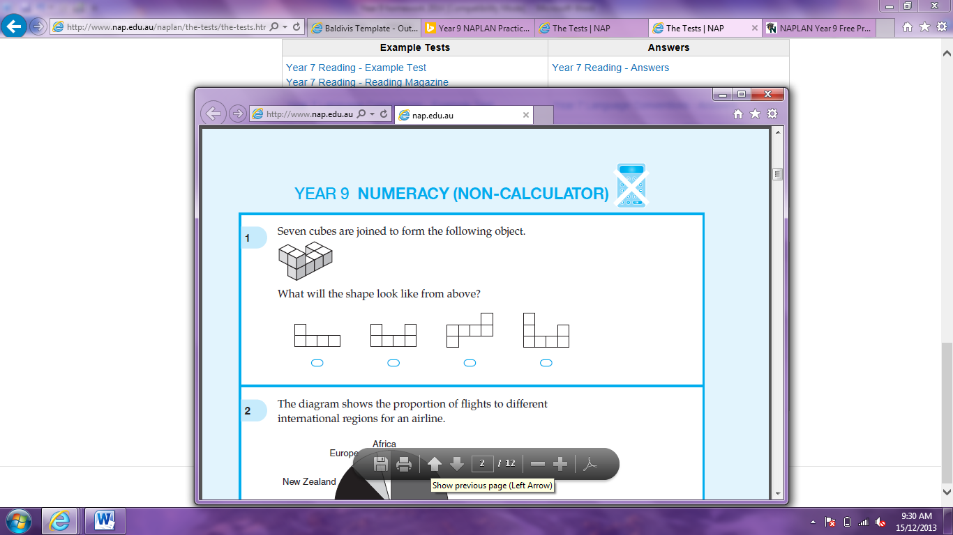
- Seven cubes are joined to form the following object.


What will the shape look like from above?






- Ben Travels 300 Km in 4 hours. What is his average speed in kilometres per hour?




60 75 90 120

- A die is tossed once. What is the probability that 5 is shown on the uppermost face?

- What is the next number in this pattern: 1, 3, 7, 15, 31, ?

- A computer chip has dimensions 8mm × 8mm. A scale drawing is shown below. What is the scale used in the drawing?
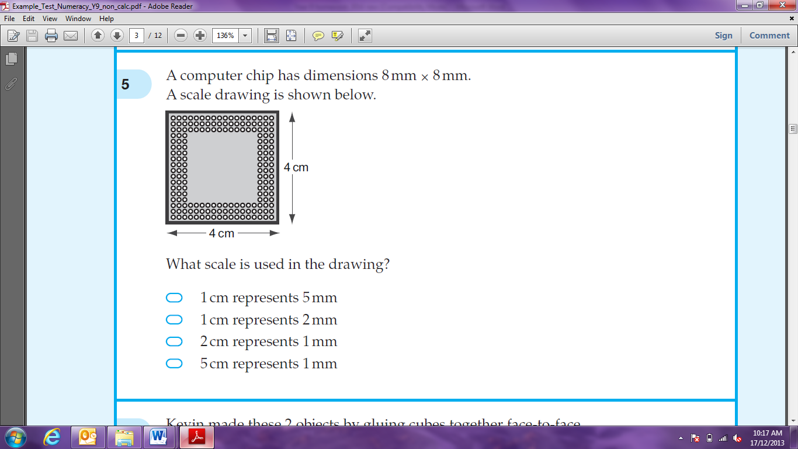

- If p =3 and q = 4, what is the value of pq?

- Which is a reflex angle?






- What is 4.2 ÷ 0.2?

- of a number is 36. What is of the number?

- Which is equivalent to 3x + 5 + 2x?




5x + 5 10x 5x² + 5 10x²

- When k = -5, what is the value of 4k?

- What is the value of y?

- The perimeter of a square is 4 metres. What is the area of the square?

- When two dice are tossed, in how many ways can you get a total of 6?

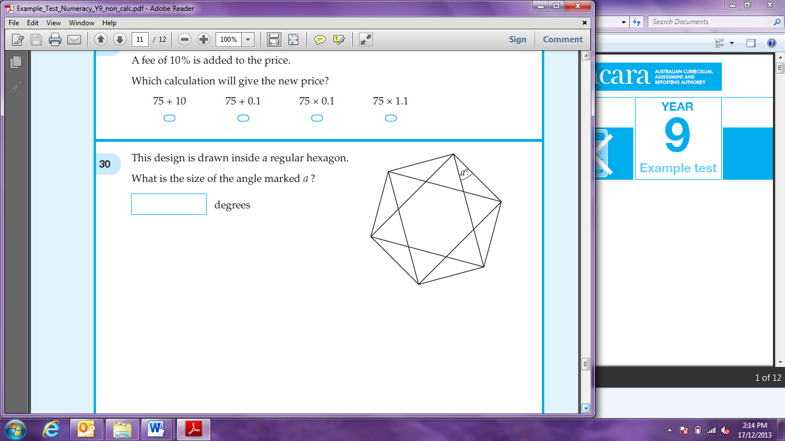
- This design is drawn inside a regular hexagon. What is the size of the angle marked a?

- What is the value of (0.3)²?

- Which two numbers multiply to -18 and add to -7?

and

